System Modelling and Design for Crowdsensed Mobile Network Monitoring System

Project Title
Crowdsensed Approach for Mobile Network Coverage Prediction and Monitoring

Group 7

1. Introduction
The rapid growth of mobile communication technologies has significantly increased the dependence of individuals, businesses, and institutions on reliable mobile network connectivity. Despite this dependence, users still experience poor network coverage, unstable signal strength, slow internet speeds, and call interruptions in many locations. In developing regions especially, users often lack access to accurate and up-to-date information about network performance in their geographical areas. Traditional network monitoring approaches used by telecommunication companies rely heavily on expensive infrastructure and specialized drive-test equipment, making continuous large-scale monitoring difficult and costly.
To address these challenges, this project proposes a Crowdsensed Mobile Network Coverage Prediction and Monitoring System. The system leverages data collected directly from mobile users’ smartphones to monitor network quality and generate coverage analytics in real time. Instead of depending solely on telecom operators, the system adopts a crowdsensing approach where mobile devices automatically collect signal measurements such as RSRP, RSRQ, RSSI, SINR, GPS coordinates, network type, and timestamps during normal device usage. These measurements are then synchronized to a centralized backend infrastructure for processing, analysis, and visualization.
The purpose of this report is to present the system modelling and design phase of the project. This phase transforms the functional and non-functional requirements defined in the Software Requirements Specification (SRS) into detailed structural and behavioral models that guide the implementation process. The models presented in this report serve as a blueprint for developers, system architects, testers, and database designers by illustrating how different components of the system interact, how data flows through the system, and how users engage with the platform.
The system is designed using an offline-first architecture. This design choice ensures that the mobile application continues collecting and storing measurements even in areas with poor or unavailable internet connectivity. Once connectivity becomes available, synchronization services upload the locally stored data to the backend server. This approach improves reliability, minimizes data loss, and ensures continuous monitoring regardless of connectivity conditions.
The system consists of four major components:
- An Android mobile application responsible for collecting network measurements and user reports.
- A backend API server responsible for data validation, synchronization, processing, and analytics generation.
- A PostgreSQL/PostGIS database responsible for persistent storage and geospatial operations.
- A web dashboard used by administrators and network operators to visualize coverage maps and analyze network trends.
The primary stakeholders of the system include regular mobile users, registered users, administrators, and network operators such as MTN, Orange, and Camtel. Each stakeholder interacts with the system differently depending on their responsibilities and objectives.
This report presents the major modelling and design artifacts for the system, including:
- Context Diagram
- Data Flow Diagram (DFD)
- Use Case Diagram
- Sequence Diagram
- Class Diagram
- Deployment Diagram
- Traceability Matrix
Together, these models ensure that the proposed solution is technically feasible, scalable, maintainable, and aligned with the project objectives and stakeholder requirements.

2. System Architecture Overview
The Crowdsensed Mobile Network Monitoring System follows a layered client-server architecture designed to support scalability, maintainability, security, and efficient data processing. The architecture separates responsibilities into independent layers, allowing each component to operate and evolve without affecting the others significantly.
The system architecture is composed of four primary layers:
- Client Layer (Android Mobile Application)
- Application Layer (Backend API Server)
- Data Layer (Database Server)
- Presentation Layer (Web Dashboard)
The overall architecture emphasizes an offline-first strategy, lightweight communication mechanisms, geospatial data processing, and secure data exchange between distributed components.

2.1 Client Layer – Android Mobile Application
The client layer consists of the Android mobile application developed using Flutter. This application serves as the primary data collection point within the system.
The mobile application is responsible for continuously monitoring mobile network conditions and collecting signal-related measurements from the Android Telephony APIs. The application collects important network parameters including:
- RSRP (Reference Signal Received Power)
- RSRQ (Reference Signal Received Quality)
- RSSI (Received Signal Strength Indicator)
- SINR (Signal-to-Interference-plus-Noise Ratio)
- Network type (2G, 3G, 4G, 5G)
- GPS coordinates
- Timestamp information
The application operates in the background using Android foreground services and WorkManager scheduling mechanisms. Measurements are collected periodically with optimized intervals to reduce battery consumption and avoid excessive resource usage.
A major architectural feature of the client layer is its offline-first capability. Measurements are stored locally in a SQLite database whenever internet connectivity is unavailable. This ensures that data collection continues seamlessly even in remote or low-connectivity areas. Once connectivity becomes available, synchronization services automatically upload unsynchronized data to the backend server.
The mobile application also provides users with the ability to:
- View signal strength information
- View coverage heatmaps
- Submit poor network reports
- Track personal measurement history
- Synchronize user accounts across devices
The client layer therefore functions both as a monitoring tool and as a user interaction platform.

2.2 Application Layer – Backend API Server
The application layer acts as the central processing unit of the entire system. It is implemented using Node.js or Go and exposes RESTful API endpoints that allow communication between the mobile application, the database, and the web dashboard.
The backend server performs several critical responsibilities including:

Data Synchronization
The backend receives measurement records from mobile devices during synchronization processes. These uploads are transmitted securely over HTTPS using compressed JSON payloads to reduce bandwidth usage.

Data Validation and Cleaning
Before measurements are stored permanently, the backend validates all incoming data to ensure accuracy and consistency. Validation mechanisms include:
- Checking acceptable signal ranges
- Removing duplicate entries
- Correcting GPS drift anomalies
- Standardizing network labels
- Filtering corrupted records
This stage is essential because crowdsensed data may contain inconsistencies caused by device limitations, poor GPS accuracy, or malicious submissions.

Coverage Analytics Generation
The backend aggregates validated measurements into geographical grid cells and computes network quality metrics. Statistical operations such as median RSRP calculations are used to determine network quality classifications such as:
- Excellent
- Good
- Fair
- Poor
The analytics engine also identifies coverage holes and areas experiencing persistent network degradation.

Report Management
The backend handles user-submitted reports regarding poor network quality. Reports are validated, scored for confidence, and flagged for suspicious activity or spam behavior before being stored.

Dashboard Services
The backend provides APIs that supply analytics data, coverage maps, and historical trends to the web dashboard used by administrators and network operators.
The backend layer therefore acts as the bridge between raw crowdsensed data and meaningful network intelligence.

2.3 Data Layer – PostgreSQL/PostGIS Database
The data layer consists of a PostgreSQL relational database enhanced with the PostGIS extension for geospatial operations.
This database stores all persistent system data including:
- User accounts
- Network measurements
- GPS coordinates
- Synchronization logs
- User reports
- Historical analytics
- Coverage classifications
PostGIS enables advanced geographical processing required for generating coverage heatmaps and performing spatial queries. Examples of spatial operations include:
- Determining measurements within a geographic boundary
- Aggregating measurements into map tiles
- Identifying high-density reporting zones
- Generating geospatial heatmaps
The database design supports indexing strategies optimized for high-volume geospatial datasets. Since the system may eventually process millions of measurement records, scalability and query optimization are important architectural considerations.

2.4 Presentation Layer – Web Dashboard
The presentation layer consists of a browser-based web dashboard developed using React.js
The dashboard provides administrators and network operators with visualization and analytical tools for interpreting crowdsensed network data.
The dashboard supports functionalities such as:
- Viewing real-time coverage heatmaps
- Monitoring network quality trends
- Filtering data by operator or region
- Viewing user reports
- Exporting analytical reports
- Managing administrative settings
Interactive maps and geospatial visualizations allow stakeholders to identify coverage gaps and monitor network performance across different geographical areas.
Unlike the mobile application, which focuses primarily on data collection, the dashboard focuses on data interpretation and decision support.

2.5 Architectural Design Principles
The architecture of the system is guided by several key design principles:

Offline-First Operation
The system prioritizes local storage and delayed synchronization to ensure continuous functionality even in unstable network environments.

Scalability
The modular architecture allows the backend and database services to scale independently as data volume and user traffic increase.

Security
All communications between clients and servers are encrypted using HTTPS. Sensitive user data is anonymized where necessary to protect privacy.

Maintainability
The separation of concerns between layers improves maintainability and simplifies future upgrades.

Reliability
Background synchronization mechanisms and local caching improve reliability and reduce the risk of data loss.

3. Behavioral and Structural Models
This section presents the behavioural and structural models used to represent the interactions, workflows, data movement, and architectural organization of the Crowdsensed Mobile Network Monitoring System. These models provide a detailed understanding of how the system operates internally and how different system components communicate with one another.
The modelling process is essential because it transforms the requirements gathered during analysis into technical representations that developers and stakeholders can easily interpret. Each model highlights a different perspective of the system, including user interactions, data processing activities, object relationships, and deployment structures.
The following models are presented in this phase:
- Context Diagram
- Data Flow Diagram (DFD Level 1)
- Use Case Diagram
- Sequence Diagram
- Class Diagram
- Deployment Diagram

3.1 Context Diagram
The context diagram provides a high-level representation of the entire system and illustrates how the system interacts with external entities. At this level, the entire Crowdsensed Network Monitoring System is treated as a single process while external actors exchange information with it through defined data flows.
The purpose of the context diagram is to establish the system boundary and identify all major stakeholders and external systems interacting with the platform.
The primary external entities identified include:

Mobile User
The mobile user represents individuals who use the Android application to monitor network conditions. The user grants the necessary permissions required for accessing GPS and network information. The mobile user also views coverage maps, submits poor network reports, and contributes crowdsensed measurements to the system.
The system receives several categories of information from the mobile user including:
- Signal measurements
- GPS coordinates
- User-generated reports
- Synchronization requests
In return, the system provides:
- Coverage maps
- Network quality indicators
- Historical monitoring data
- Feedback regarding submitted reports

Administrator
The administrator interacts with the system through the web dashboard and is responsible for managing the operational aspects of the platform. Administrative responsibilities include reviewing reports, moderating suspicious submissions, monitoring system performance, and configuring platform settings.
The administrator primarily exchanges analytical queries and management commands with the system.

Network Operator
Network operators such as MTN, Orange, and Camtel use the dashboard to analyze crowdsensed network performance within their operational regions. Operators access heatmaps, trend analysis reports, and network quality statistics generated from aggregated user measurements.
This stakeholder benefits from the analytics generated by the system but does not directly participate in data collection.

GPS Satellite System
The GPS subsystem acts as an external hardware service that provides geographical coordinates to mobile devices. These coordinates are combined with signal measurements to create geospatial network records.

Cellular Network Infrastructure
Cellular towers and mobile communication infrastructure provide the radio signals being measured by the Android application. The system passively collects signal quality information from these interactions without directly interfacing with telecom infrastructure.
The context diagram therefore demonstrates that the system acts as a centralized platform that collects, processes, analyzes, and redistributes mobile network intelligence between users and network stakeholders.

3.2 Data Flow Diagram (DFD Level 1)
The Data Flow Diagram expands the high-level context model into major internal processes and illustrates how information moves throughout the system.
The DFD identifies the major processing activities, data stores, and transformations involved in the monitoring and analytics workflow.
The system is decomposed into several key processes.

Process 1: Collect and Store Local Data
This process occurs within the Android mobile application. The application continuously retrieves network measurements from Android telephony services and combines them with GPS coordinates obtained from location services.
Once measurements are collected, the application structures the information into standardized records and stores them in the local SQLite database.
This process is designed to operate even when the device lacks internet connectivity. Local storage ensures that measurements are preserved until synchronization becomes possible.

Process 2: Synchronize Data
The synchronization process is responsible for transferring locally stored records from the mobile device to the backend server.
Synchronization is triggered periodically or whenever connectivity conditions improve. Before transmission, the application compresses measurement payloads to minimize bandwidth consumption.
The synchronization mechanism also tracks upload status to prevent duplicate transmissions.

Process 3: Validate and Clean Data
This process occurs on the backend server and ensures that crowdsensed data is reliable before permanent storage.
Validation operations include:
- Signal range verification
- Duplicate detection
- Timestamp consistency checks
- GPS anomaly correction
- Device integrity validation
This process improves the quality and trustworthiness of analytical results generated later in the pipeline.

Process 4: Generate Coverage Analytics
Validated measurements are aggregated into geographical grid structures used for generating heatmaps and quality statistics.
The analytics engine computes statistical summaries such as median RSRP values and classifies coverage quality into predefined categories.
Areas with consistently poor measurements are identified as coverage holes and highlighted on visualization maps.

Process 5: Manage User Reports
This process handles reports submitted by users regarding poor network experiences.
The backend validates report contents, associates reports with geographical regions, computes confidence scores, and flags potentially malicious submissions.
This reporting mechanism supplements automated measurements with human experience data.

Process 6: Visualize Dashboard Data
The dashboard visualization process retrieves analytical results from the database and renders them into interactive visual components.
Administrators and network operators can filter results by operator, region, or time period. Visualization tools include:
- Heatmaps
- Trend graphs
- Regional quality summaries
- Historical analytics
The DFD therefore illustrates the complete lifecycle of crowdsensed data, from collection at the mobile device level to analysis and visualization at the dashboard level.

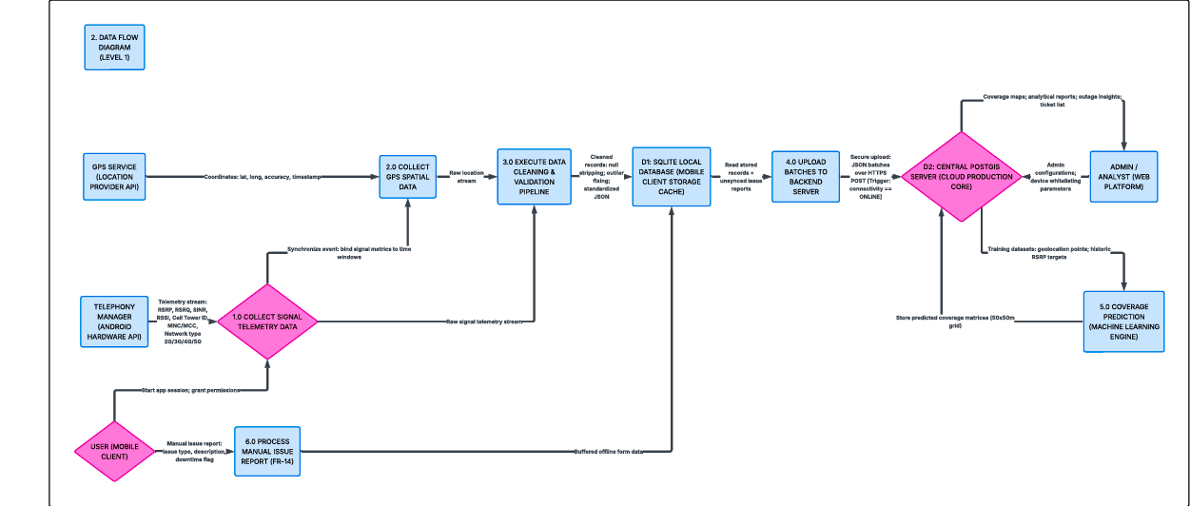

3.3 Use Case Diagram
The use case model identifies the interactions between users and the system based on the functional requirements defined in the SRS.
The diagram captures how different categories of users engage with the platform and highlights the services provided to each actor.
The primary actors include:
- Regular Mobile User
- Registered User
- Administrator
- Network Operator
The Regular Mobile User interacts primarily with the monitoring features of the mobile application. This user can view signal strength information, visualize coverage maps, and submit network quality reports.
The Registered User extends the capabilities of the regular user by enabling account synchronization and personalized historical tracking. Registered users can synchronize measurement history across devices and access long-term analytics regarding their personal monitoring activity.
The Administrator is responsible for overseeing platform operations. Administrative use cases include reviewing reports, moderating suspicious submissions, managing user activity, and monitoring analytics.
The Network Operator actor focuses mainly on analytical operations. Operators can analyze operator-specific coverage maps, identify weak coverage zones, and export analytical reports for infrastructure planning.
Several relationships exist between use cases. For example, synchronization functionality extends standard monitoring behaviour because it is available only to authenticated users. Similarly, data collection includes offline storage operations because local persistence is mandatory for all monitoring activities.
The use case model therefore demonstrates how the system supports multiple stakeholder categories while maintaining clear separation of responsibilities and permissions.

3.4 Sequence Diagram
The sequence diagram models the chronological interaction between system components during a critical operational scenario.
The selected scenario focuses on automatic network measurement collection and offline synchronization because this represents one of the most important functional requirements of the entire system.
The sequence begins when a mobile user moves into a new geographical location. The Android application continuously monitors network conditions in the background.
The application first requests signal measurements from Android telephony services. The operating system returns signal quality parameters including RSRP, RSRQ, RSSI, and SINR values.
Next, the application requests geographical coordinates from the GPS provider. The location subsystem returns latitude and longitude values associated with the current device position.
The application then combines these measurements into a structured network record containing:
- Signal measurements
- GPS coordinates
- Network type
- Timestamp
- Device identifiers
The record is stored locally inside the SQLite database.
At this stage, no internet connection may be available. Therefore, synchronization is postponed while the monitoring service continues operating normally.
Later, when connectivity becomes available, the background synchronization worker activates automatically. The synchronization service retrieves all unsynchronized records from local storage and compresses the payload before transmission.
The payload is then transmitted securely to the backend API over HTTPS.
The backend validates the records, removes invalid entries, and stores approved measurements in the PostgreSQL/PostGIS database.
Once synchronization is completed successfully, the mobile application updates the synchronization status of the uploaded records to prevent duplicate uploads.
This sequence demonstrates the offline-first architecture of the system and highlights how reliability and data persistence are maintained despite unstable network conditions.
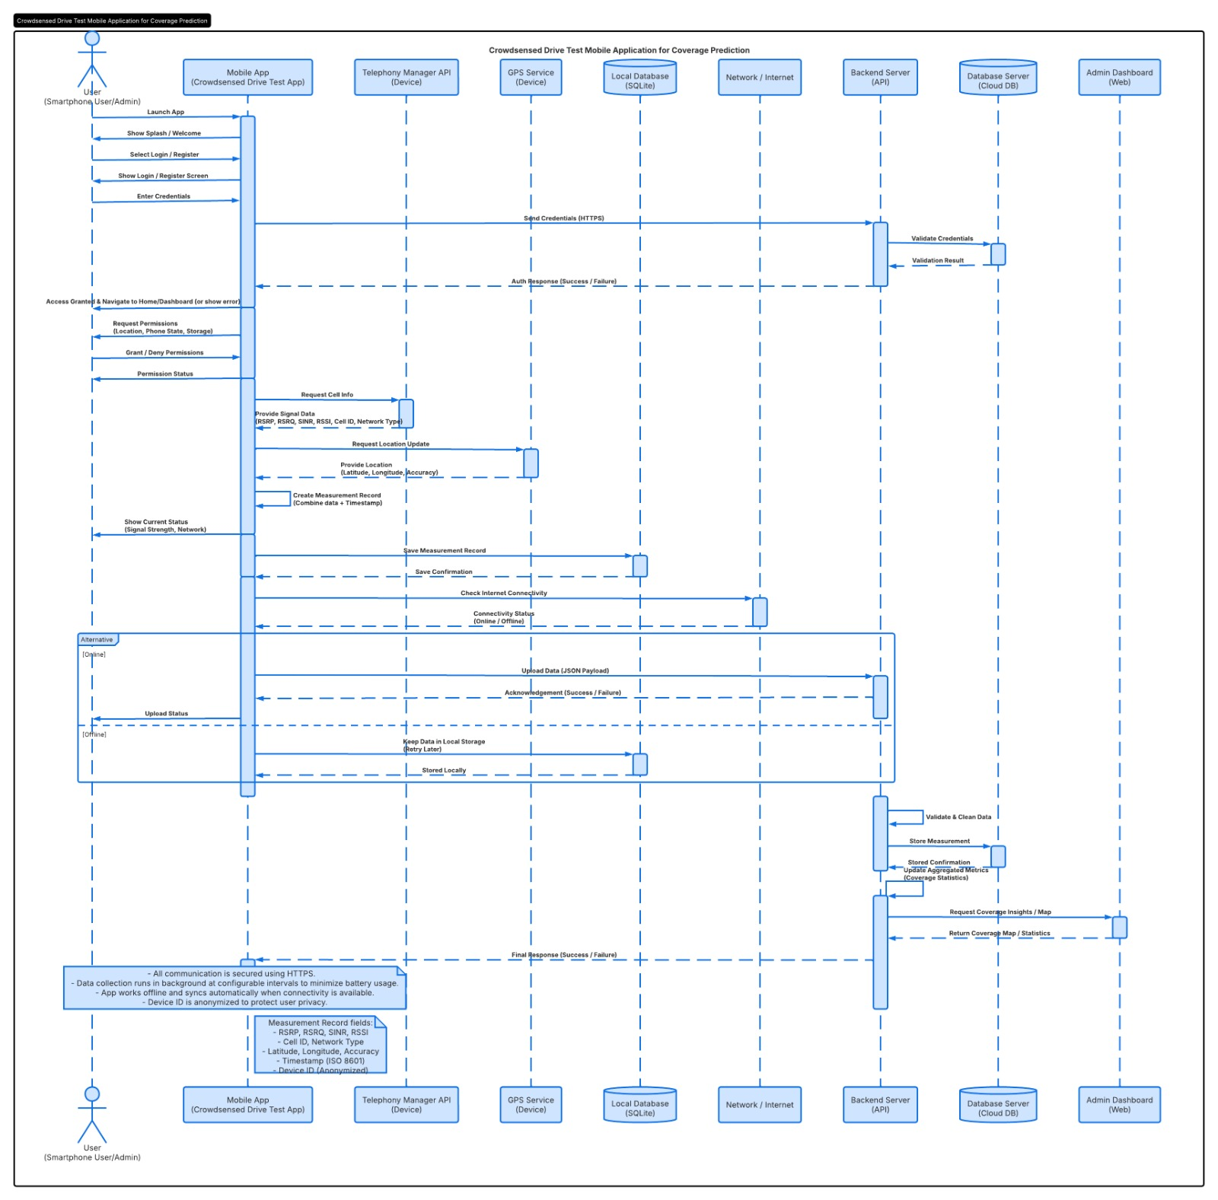

3.5 Class Diagram
The class diagram models the static structure of the system by identifying the major classes, entities, attributes, and relationships required for implementation.
The mobile application contains several important classes.
The MainActivity class acts as the entry point of the Android application and manages user interface initialization and permission requests.
The MonitoringService class handles background measurement collection and periodic monitoring operations. This service interacts with Android telephony and GPS APIs to retrieve network information continuously.
The NetworkMeasurement class represents a measurement entity containing signal strength metrics, location information, timestamps, and network metadata.
The LocalDatabase class manages persistent storage using SQLite and Room database abstractions.
The SyncWorker class handles background synchronization tasks and communicates with the backend server.
The Report class models user-submitted reports regarding poor network conditions.
On the backend side, the MeasurementController class manages incoming measurement uploads and coverage retrieval requests.
The ReportController class processes user reports and administrative moderation actions.
The CoverageService class generates heatmaps, computes analytical summaries, and identifies coverage holes.
The DataCleaner class validates incoming data and removes anomalies before storage.
The PostGISRepository class performs geospatial database queries and spatial aggregations.
Relationships between these classes illustrate how measurement objects are created, stored, synchronized, validated, processed, and visualized throughout the system lifecycle.

3.6 Deployment Diagram
The deployment diagram represents the physical arrangement of hardware and software components required for system operation.
The Android mobile device hosts the mobile monitoring application together with supporting components such as SQLite storage, GPS hardware interfaces, and Android runtime services.
The mobile application communicates securely with the backend server over HTTPS.
The backend server is deployed on cloud infrastructure such as AWS EC2 or DigitalOcean and hosts the REST API services. The server may run Node.js or Go runtime environments together with Nginx reverse proxy services.
The backend communicates with the PostgreSQL/PostGIS database server using secured database connections.
The database server stores all persistent system information including measurement records, user accounts, reports, and geospatial analytics data.
Administrators and network operators access the dashboard through web browsers running on desktop or laptop computers. These clients communicate with the backend server over HTTPS to retrieve analytical information and visualization data.
The deployment model therefore demonstrates how distributed system components interact within a secure cloud-based infrastructure environment.

4. Traceability Matrix
The traceability matrix establishes relationships between the functional requirements defined in the SRS and the design models developed during the modelling phase.
This mapping ensures that every requirement identified during requirements analysis is properly addressed within the system design.
Requirements related to automatic monitoring are represented in the sequence diagram, class diagram, and data flow diagram because these models describe measurement collection workflows and background services.
Requirements associated with GPS-based coverage visualization are represented in the use case and class diagrams since they involve user interactions and geospatial entities.
Offline synchronization requirements are represented in the sequence diagram, deployment diagram, and DFD because they involve local storage, connectivity management, and backend communication.
Reporting functionalities are represented in the use case and class diagrams through report entities and moderation workflows.
Dashboard and analytics requirements are represented in the deployment and use case diagrams because they involve visualization services and operator interactions.
Security requirements are represented primarily within the deployment model through HTTPS communication mechanisms and secure infrastructure arrangements.
This traceability process confirms that the proposed system design remains fully aligned with the requirements captured in the Software Requirements Specification.

5. Conclusion
This report has presented the complete system modelling and design phase for the Crowdsensed Mobile Network Coverage Prediction and Monitoring System. The models developed in this phase transform the abstract requirements defined in the Software Requirements Specification into detailed technical representations that guide implementation activities.
The system architecture was designed using a layered client-server model that supports scalability, maintainability, offline operation, and secure communication. The behavioural and structural models collectively describe how users interact with the platform, how data flows across components, how synchronization occurs under unstable connectivity conditions, and how analytical results are generated and visualized.
The context diagram established the system boundaries and stakeholder interactions, while the Data Flow Diagram illustrated the lifecycle of crowdsensed measurements from collection to visualization. The use case model identified the functional services available to each category of stakeholder, and the sequence diagram detailed the operational workflow of offline-first synchronization.
The class diagram provided a structural blueprint for both the mobile and backend application components, while the deployment diagram demonstrated the physical infrastructure and communication architecture required for system operation.
Overall, the models presented in this report ensure that the system design remains aligned with the functional and non-functional requirements identified during analysis. Particular attention was given to critical project objectives such as offline reliability, battery efficiency, secure communication, scalability, and geospatial analytics support.

